**Mobile App How To**

# App Setup Configuration

1. Download and install the PRO Software app to your smart phone using the QR codes below

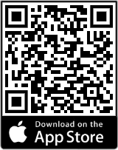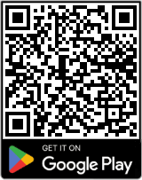

1. Once installed, enter the Company Code: **gms**
2. Click Login
3. Enter your Username and Password, and Click Login
4. Select Yes or No when prompted to use Biometric Authentication (Selecting Yes is recommended for future ease of logging in).
5. You will be prompted to enter a verification code. Select the method (email or text) and click to send the verification code. Once received, enter the code and click “Submit”.
6. You will then be asked one of your challenge questions. Enter the answer to the

question and click “Submit”. (If biometrics are enabled, this will only occur on the first login.)

1. 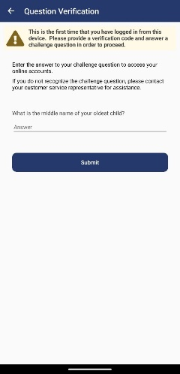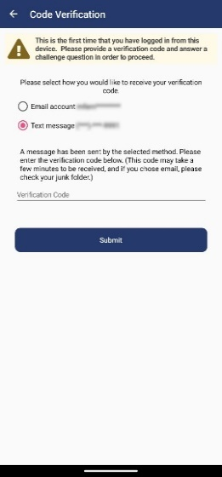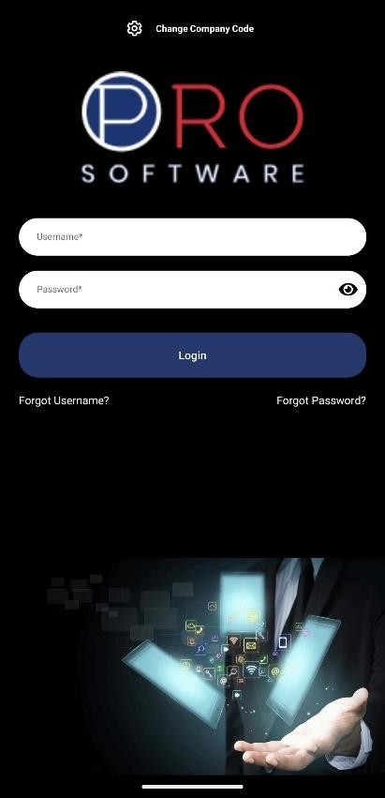Once login is complete, Select Time & Attendance to access the mobile clock.

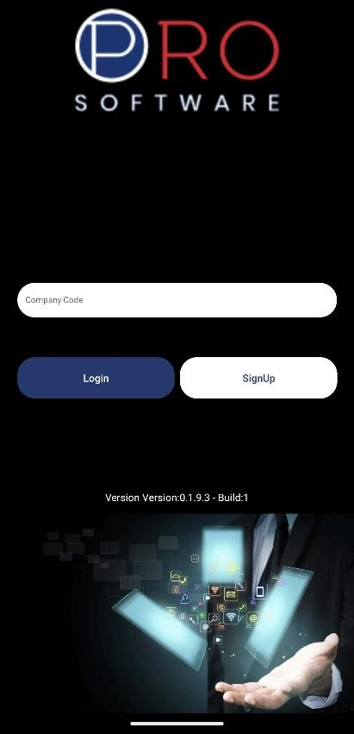

# Clocking In

* + Click Time & Attendance 🡪 Click Clock In 🡪 Click Ok

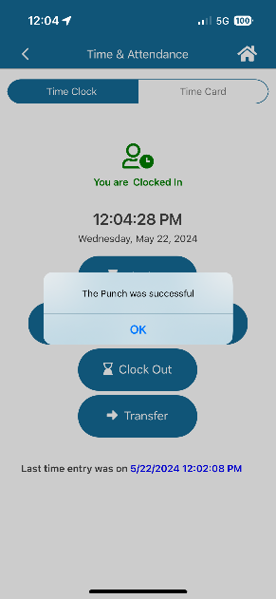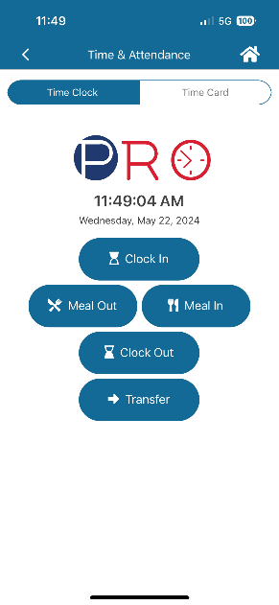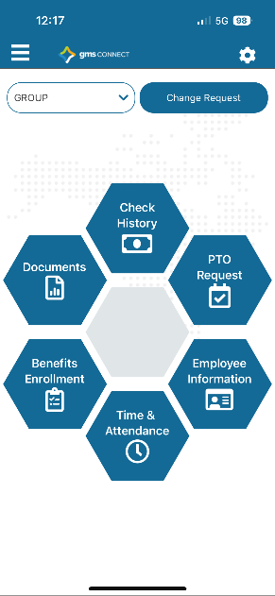

# Clocking In with Tracking Levels (if applicable)

* + 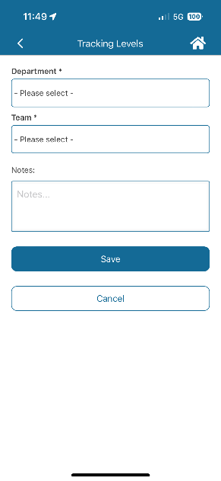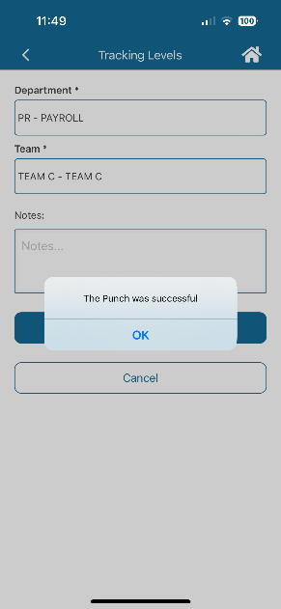Click Time & Attendance 🡪 Click Clock In 🡪 Fill out the tracking levels & save 🡪 Click Ok



# Change Tracking Levels (if applicable)

* + Click Transfer 🡪 Fill out the tracking levels & save 🡪 Click Ok

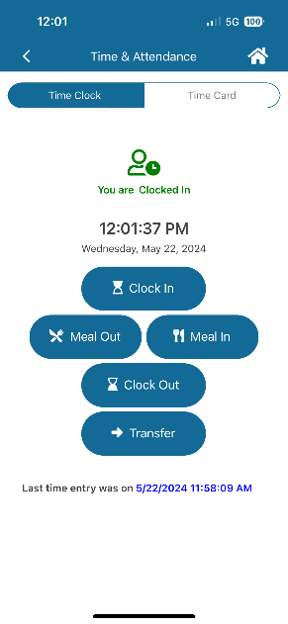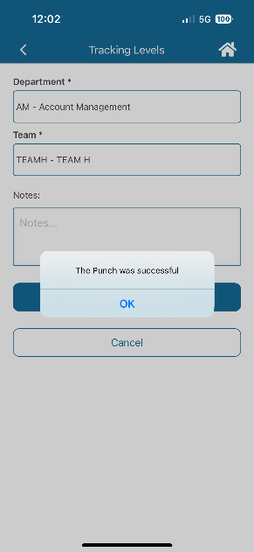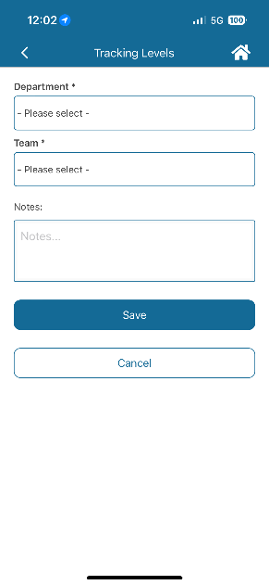8

# Leave On Meal

* Click Meal Out 🡪 The icon will now display as a meal and state “You are on a meal break.”

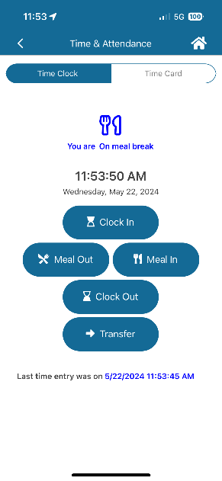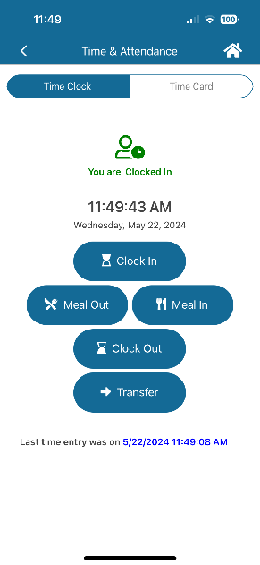

# Return From Meal

* Click the Meal In button 🡪 Select any tracking levels if applicable 🡪 The icon will again turn green and state “You are clocked in.”

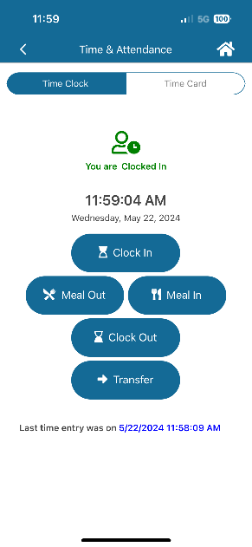

# Clock Out

* + Click Clock Out 🡪 Click Ok

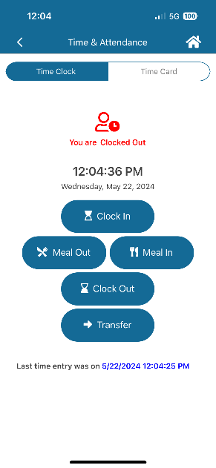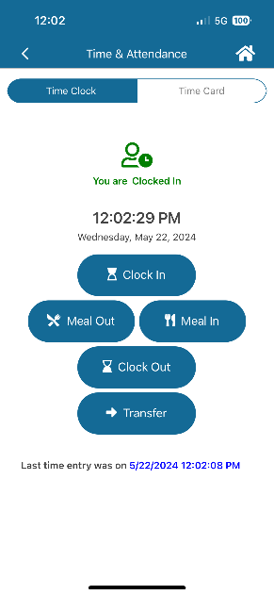

# Missed Punch

* + Enter the time in/out and click Save 🡪 Click Ok

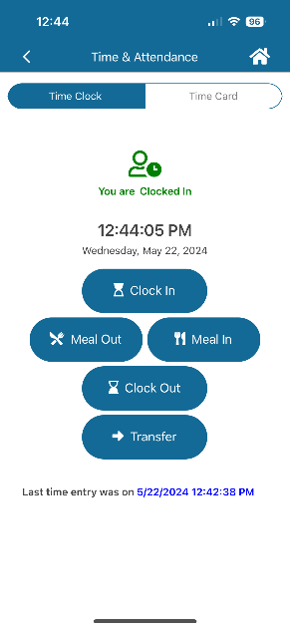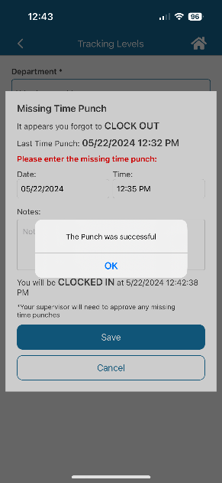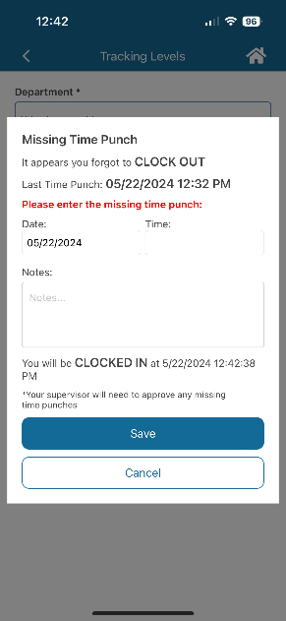

# Viewing Hours and Adding Notes

* + **To View Hours:** Click Time Card
  + **Add a Note:** Click Time Card 🡪 Click on the note icon 🡪 Type your note and click Save

