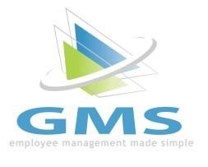**Employee Portal Clock**

1. **Clocking In**

* Navigate to the Employee Portal and log in. Scroll down to the time clock widget on the Dashboard and click Clock In. The icon on the widget will now turn green and state “You are clocked in.”

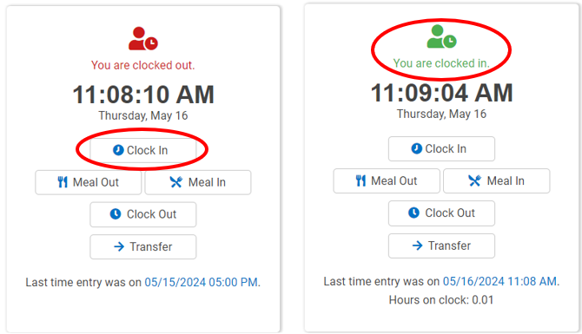

1. **Clocking In with Tracking Levels (if applicable)**

* Navigate to the Employee Portal and log in. Scroll down to the time clock widget on the Dashboard and click Clock In.

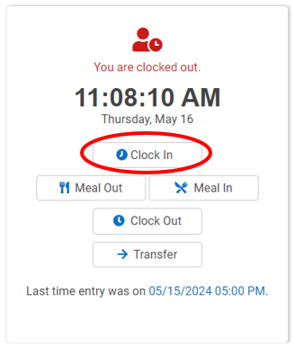

* Select tracking levels required and click Continue.

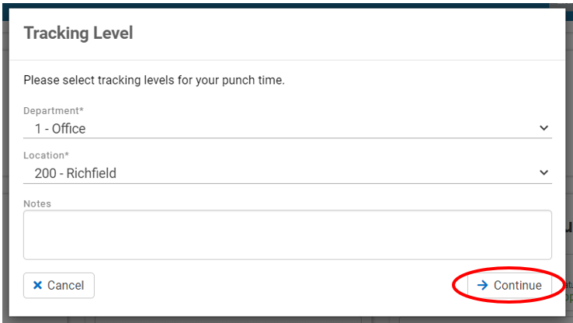

* The icon on the widget will now turn green and state “You are clocked in.”

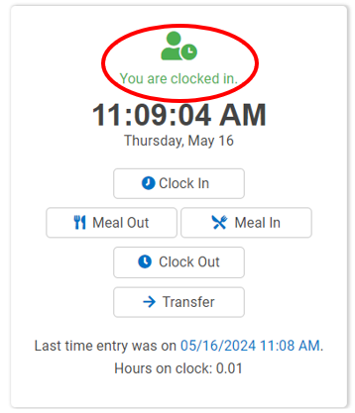

1. **Leave On Meal**

* Select the Meal Out button. The icon will now display as a meal and state “You are on a meal break.”

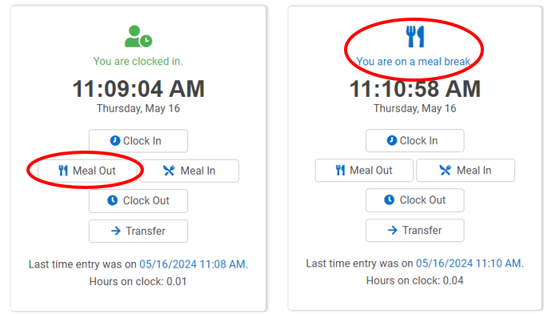

1. **Return From Meal**

* Click the Meal In button.

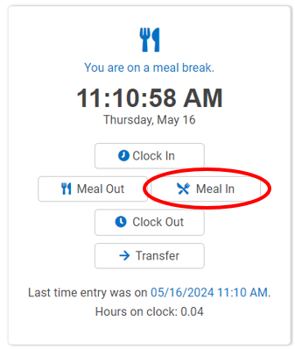

* Select any tracking levels if applicable and click Continue.

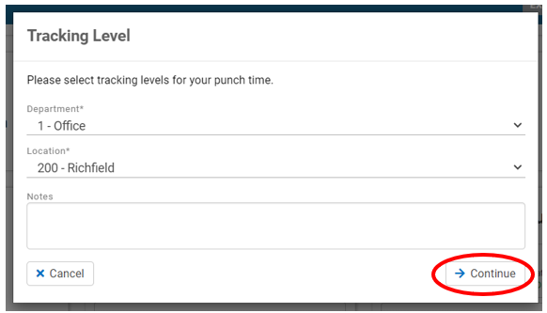

* The icon will again turn green and state “You are clocked in.”

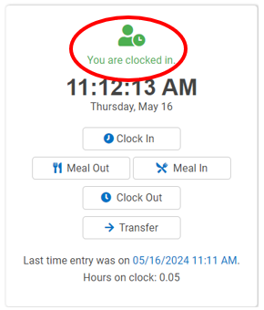

1. **Changing Tracking Levels(if applicable)**

* Click the Transfer button.

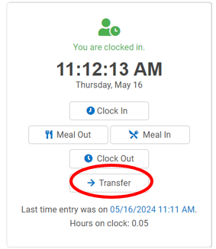

* Select the required tracking levels, then click Continue.

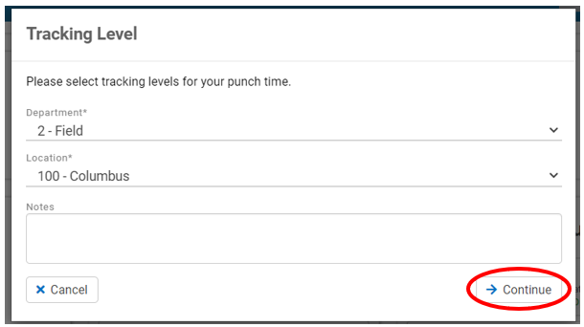

1. **Clocking Out**

* Click the Clock Out button. The icon will now display in red and state “You are clocked out.”

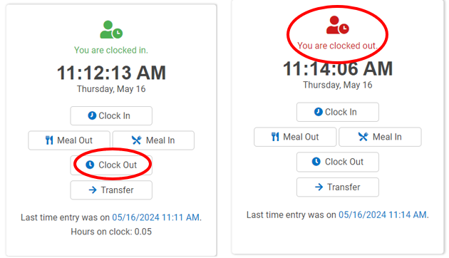

1. **Viewing Hours**

* Click on the Time & Attendance tab on the left side of the screen, then click on the Time Card tab.

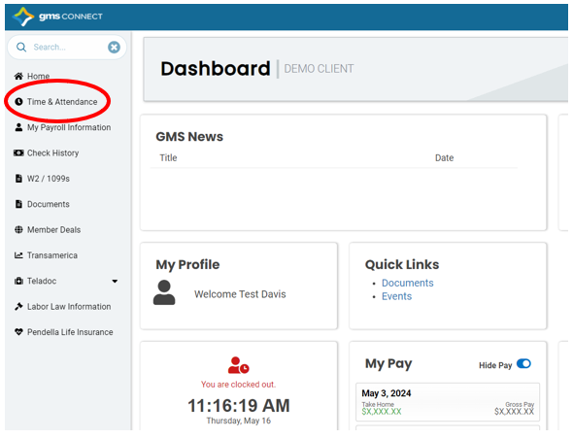

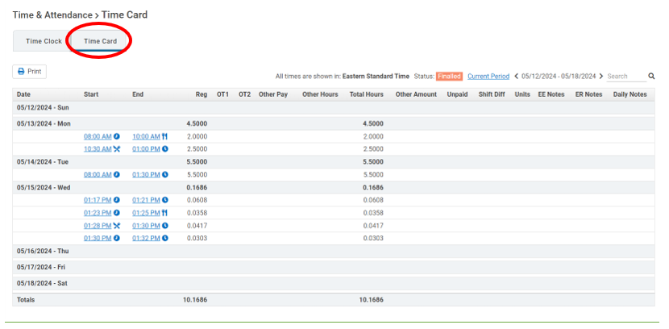

1. **Viewing Schedules(if applicable)**

* Click the Shift Scheduler tab on the left side of the screen to view your schedule.

