
Managing Time Cards

- Reviewing, Editing, and Approving Hours
  - Reviewing Hours
- Navigate to the Employee tab – Time Cards.
- Select the last day of the pay period you wish to review. A pay period summary will then populate below.
- Double click the employee name or click on the eye icon at the end of the row to view each employees’ daily punches.
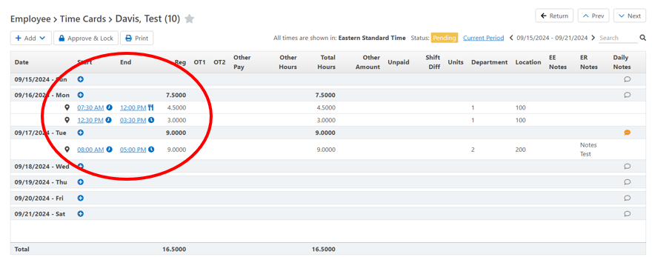
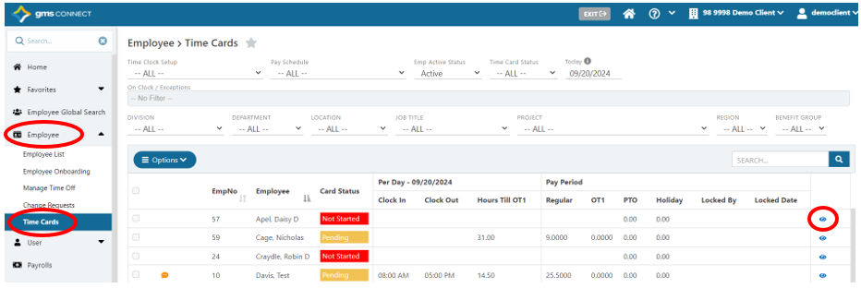

  - Editing Hours
- Navigate to the employees’ daily punches. Click on the start or end time to be edited. Complete desired edits to Date, Time, or Tracking Level, then Save.
- To make additions, click Add at the top of the screen to add lump sum hours, units, or dollar amounts. Fill in the required fields and Save.
- To add time punches, click on the “+” button beside the specific date you would like to add time, and fill in all required fields, then Save. Note: you will need to create entries for each clock operation individually (such as Clock In, Meal Out, Meal In, Clock Out).

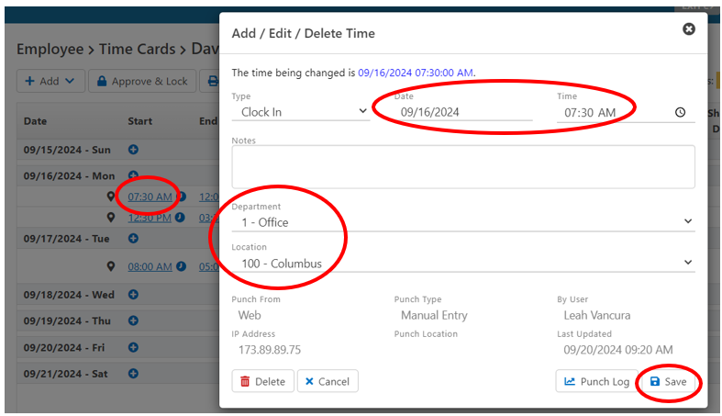

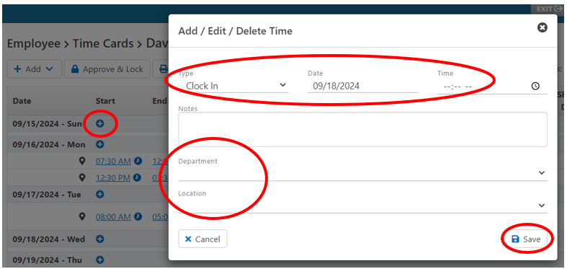

  - Approving Hours
- To approve hours individually, navigate to employees’ daily punches, be sure the correct pay period is selected on the top right, then click the Approve & Lock button.
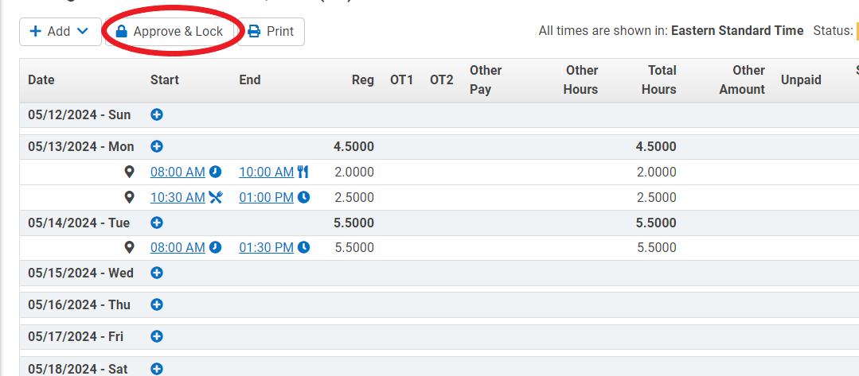

- To approve hours in bulk, navigate to the Employee – Time Cards screen, be sure the correct Pay Schedule is selected, check the boxes next to each employee whose time you would like to approve (check the top box to select all), then click the Options button, and choose the Bulk Approve Time Cards selection Then choose the correct pay period to be approved, and click Approve & Lock.
