**Importing Time Cards**

* Once hours are approved, you will navigate to Payrolls and select “New Payroll.”

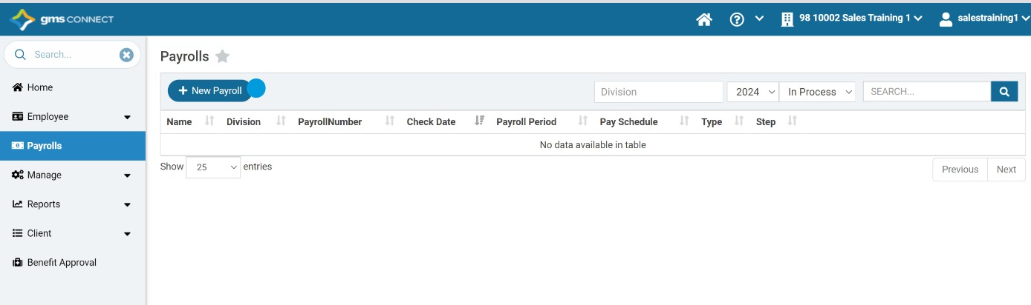

* Select “Start Payroll.”

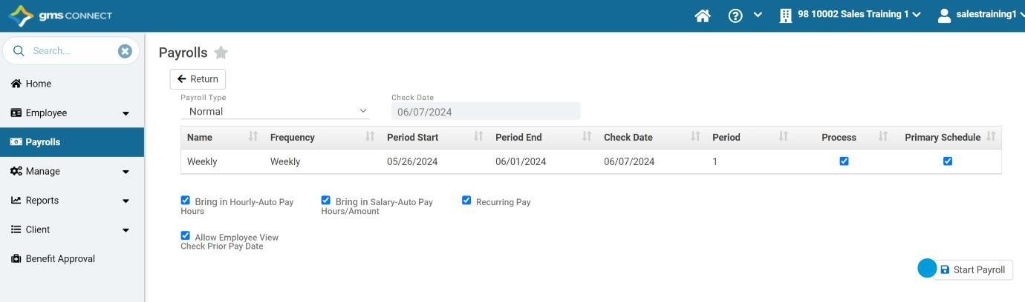

* Select “Options” and choose “Upload Time.”

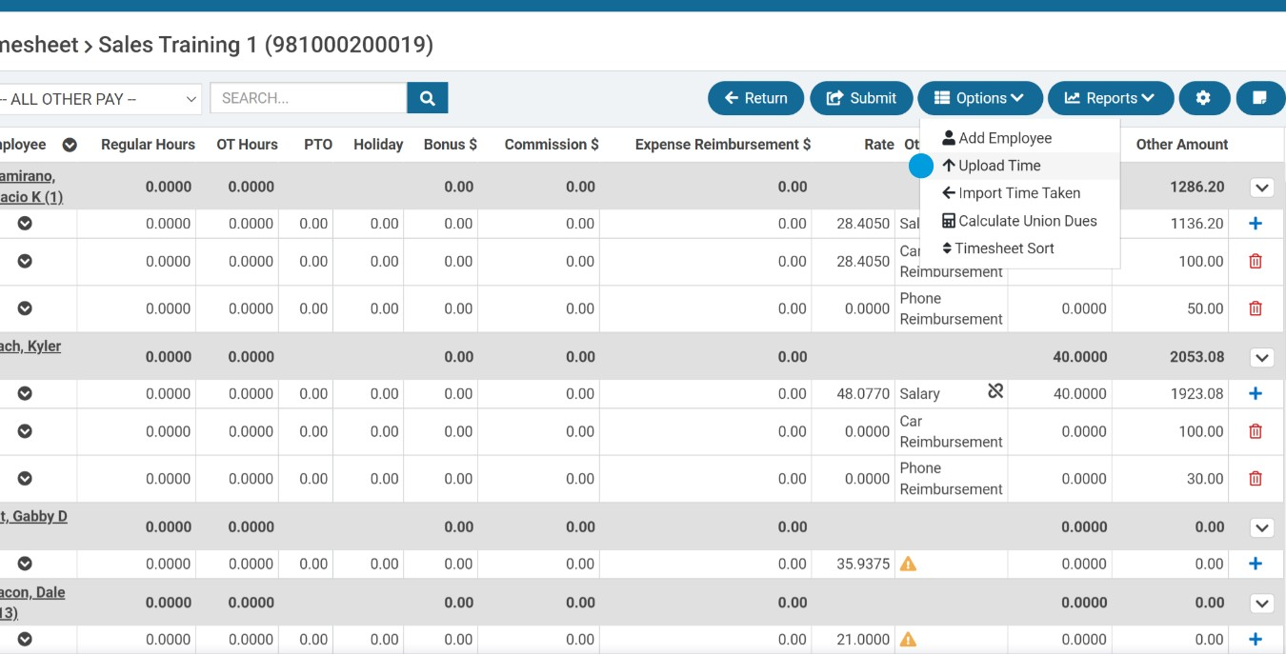

* Select “Import Times.”

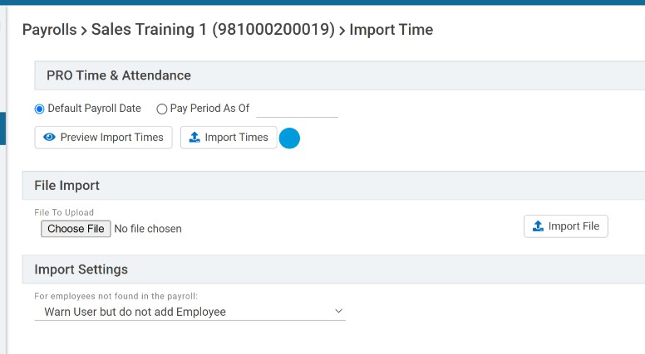

* Select all employees and choose “Import.”

