**Binding Pro PIN Clock**

* Navigate to the Time & Attendance Setup tab🡪PIN Clock Setup
* Select the PIN clock name and click the Bind PIN Clock button.

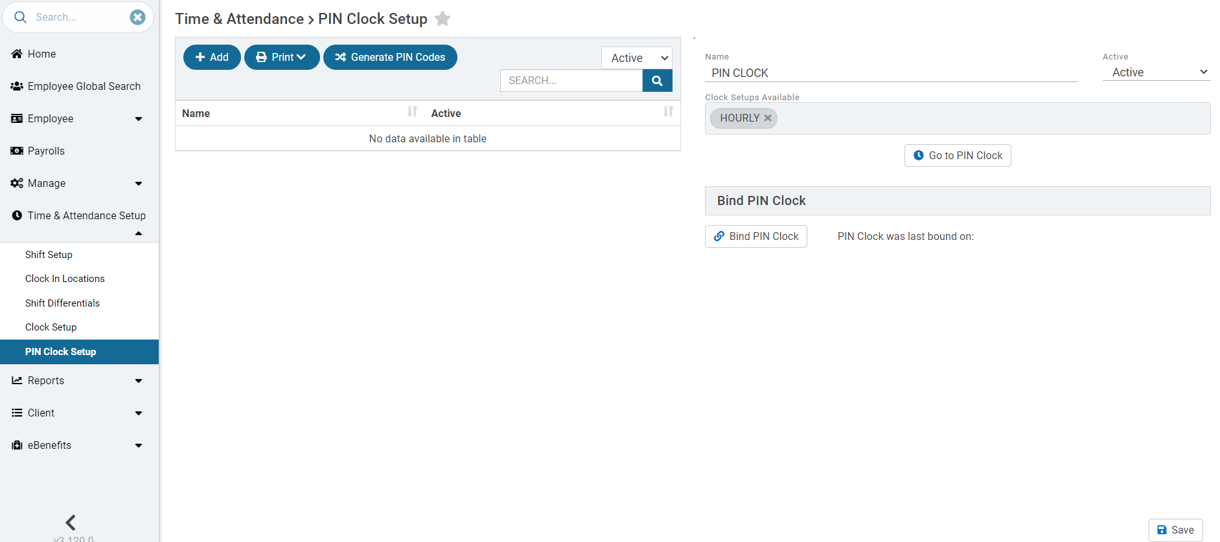

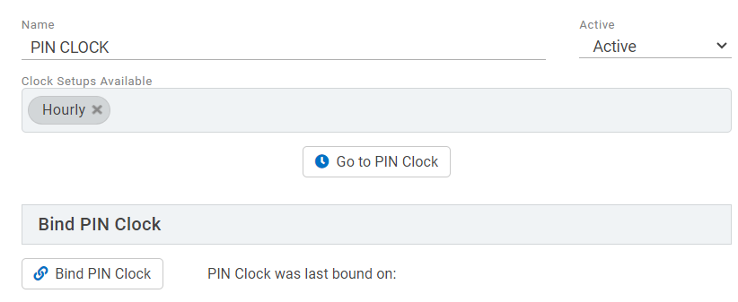

* Select OK to the pop-up message below.

* Click on the Go to PIN Clock button or navigate to <https://connect.gms.online/timeclockpinclock.html> and copy the binding PIN.

* Paste the PIN in the binding code field below. Click bind PIN clock.

* Navigate back to **https://connect.gms.online/timeclockpinclock.html** in a new tab.
* Save this page to your favorites or set as the browser’s default homepage.

